***C++ LAB TASK-2 WITH SOLUTIONS***

**1.Write a C++ program to accept two integers and check whether they are equal or not.**

**#include<iostream>**

**using namespace std;**

**class ins**

**{**

**public:**

**int num1, num2;**

**};**

**int main()**

**{**

**ins ip;**

**cout<<"Enter The First Number:";**

**cin>>ip.num1;**

**cout<<"Enter The Second Number:";**

**cin>>ip.num2;**

**if(ip.num1==ip.num2)**

**{**

**printf("Two Numbers are Equals");**

**}**

**else**

**{**

**printf("Two Numbers are Not Equals");**

**}**

**return 0;**

**}**

**Output:**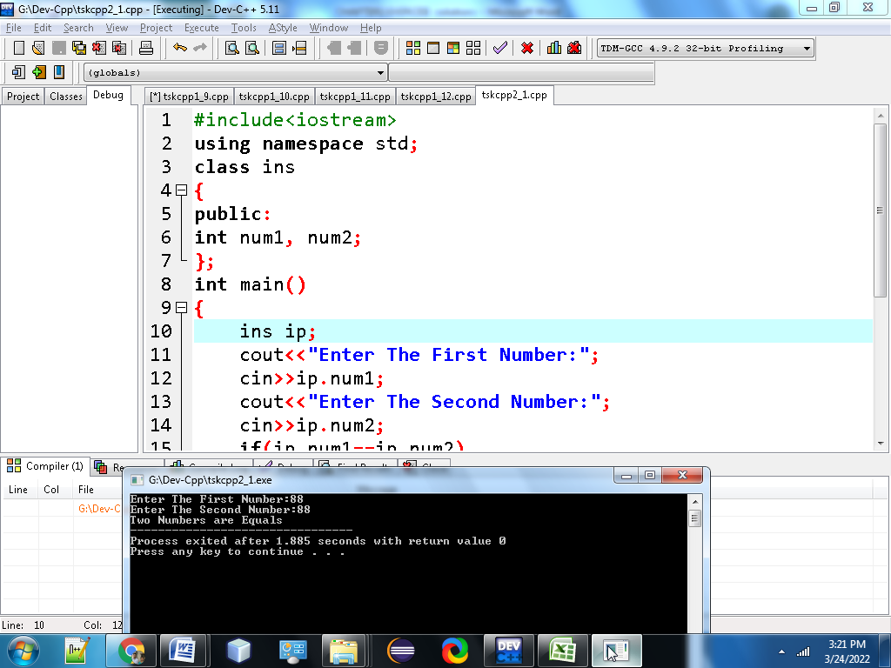

**2. Write a C++program to check whether a given number is even or odd.**

**#include<iostream>**

**using namespace std;**

**class oe**

**{**

**public:**

**int n;**

**};**

**int main()**

**{**

**oe o1;**

**cout<<"Enter The Number to Find Odd or Even:";**

**cin>>o1.n;**

**if(o1.n%2==0)**

**{**

**cout<<"The Given Number is Even Number";**

**}**

**else**

**{**

**cout<<"The Given Number is Odd Number";**

**}**

**return 0;**

**}**

**Output:**

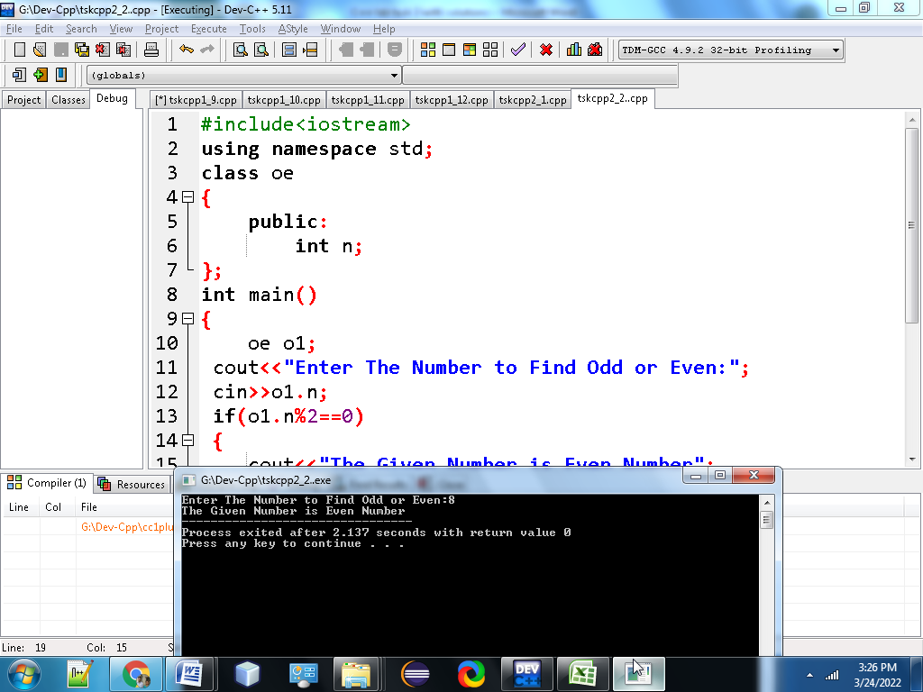

**3. Write a C++program to check whether a given number is positive or negative?**

**#include<iostream>**

**using namespace std;**

**class posneg**

**{**

**public:**

**int a;**

**};**

**int main()**

**{**

**posneg pn;**

**cout<<"Enter The Number To Find Positive or Negative Number:";**

**cin>>pn.a;**

**if(pn.a>0)**

**{**

**cout<<"Given Number is Positive Number";**

**}**

**else if(pn.a<0)**

**{**

**cout<<"Given Number is Negative Number";**

**}**

**else**

**{**

**cout<<"The Given Number is Neutral Number";**

**}**

**return 0;**

**}**

**Output:**

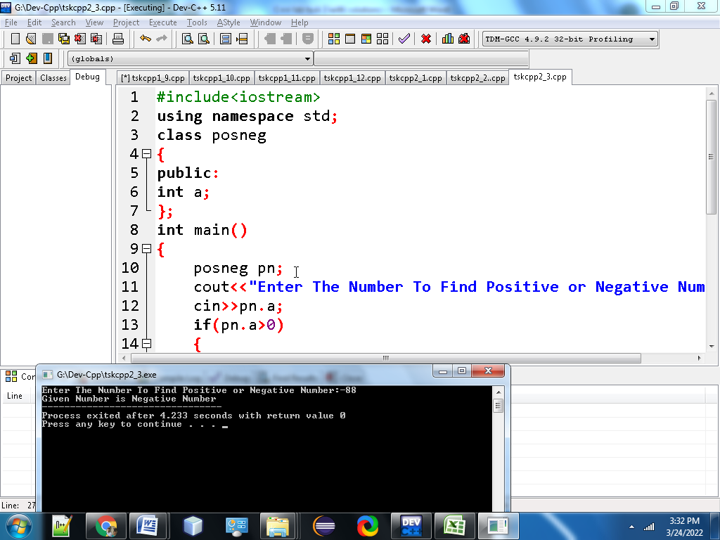

**4.Write a C++ program to find whether a given year is a leap year or not.?**

**#include <iostream>**

**using namespace std;**

**class leap**

**{**

**public:**

**int year;**

**};**

**int main() {**

**leap lp;**

**cout<<"Enter a year:";**

**cin>>lp.year;**

**if (lp.year % 400 == 0)**

**{**

**cout<<lp.year<<"is a leap year"<<lp.year;**

**}**

**else if (lp.year % 100 == 0) {**

**cout<<lp.year<< "is not a leap year",lp.year;**

**}**

**else if (lp.year % 4 == 0) {**

**cout<<lp.year<<"is a leap year",lp.year;**

**}**

**else {**

**cout<<lp.year<<"is not a leap year",lp.year;**

**}**

**return 0;**

**}**

**Ouput:** 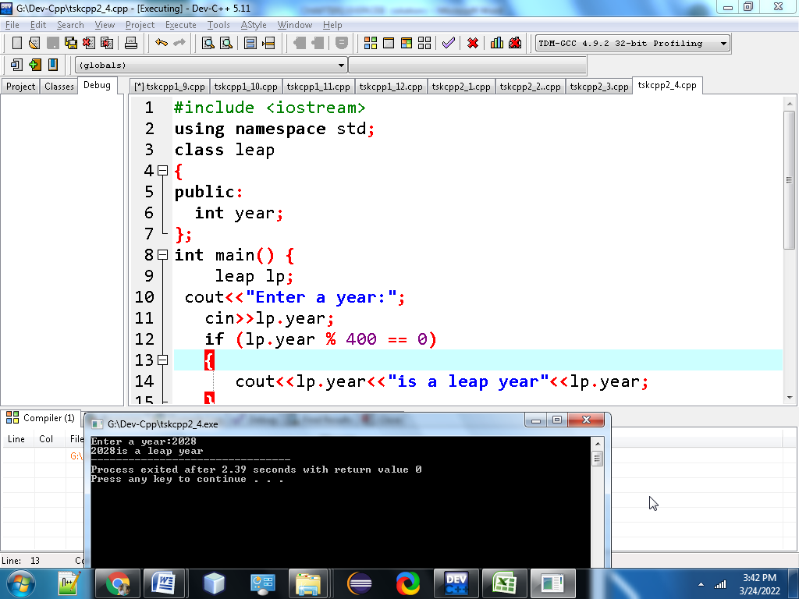

**5.Write a C++ program to read the age of a candidate and determine whether it is eligible for casting his/her own vote.**

**#include<iostream>**

**using namespace std;**

**class vote**

**{**

**public:**

**int age;**

**};**

**int main()**

**{**

**vote vte;**

**cout<<"Enter Your age:";**

**cin>>vte.age;**

**if(vte.age>=18)**

**{**

**cout<<"You are Eligible to vote";**

**}**

**else**

**{**

**cout<<"You are Not Eligible to vote";**

**}**

**return 0;**

**}**

**Output:**

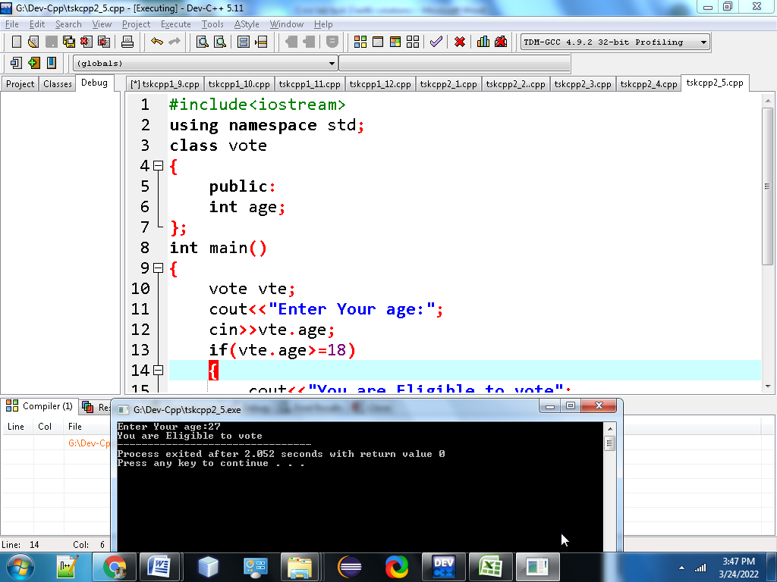

**6.Write a C++ program to read the value of an integer m and display the value of n is 1 when m is larger than 0, 0 when m is 0 and -1 when m is less than 0.**

**#include<iostream>**

**using namespace std;**

**class nps**

**{**

**public:**

**int m,n;**

**};**

**int main()**

**{**

**nps np;**

**cout<<"Input the value of m :";**

**cin>>np.m;**

**if(np.m!=0)**

**{**

**if(np.m>0)**

**{**

**np.n=1;**

**}**

**else**

**{**

**np.n=-1;**

**}**

**}**

**else**

**{**

**np.n=0;**

**}**

**cout<<"The value of m ="<<np.m<<endl;**

**cout<<"The value of n ="<<np.n;**

**return 0;**

**}**

**Output:** 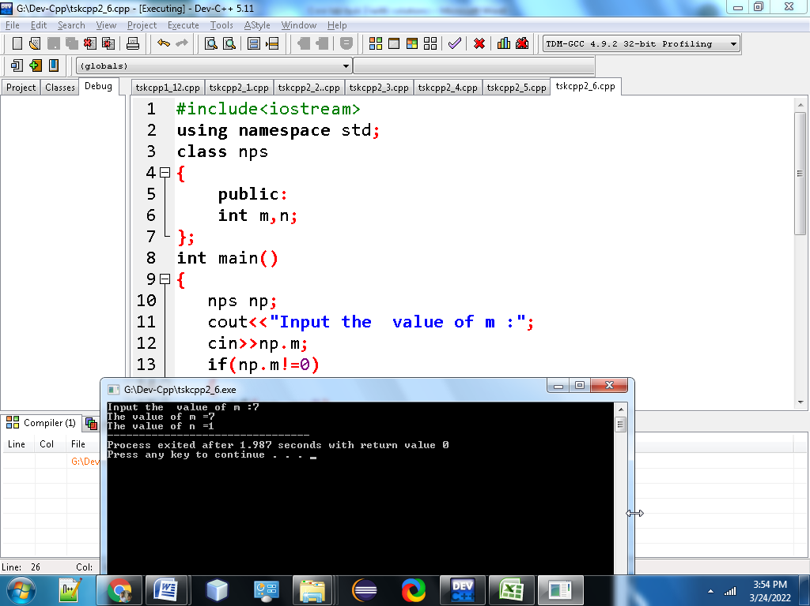

**7. Write a C++ program to accept the height of a person in centimeter and categorize the person according to their height.?**

**#include<iostream>**

**using namespace std;**

**class Ht**

**{**

**public:**

**float PerHeight;**

**};**

**int main()**

**{**

**Ht h1;**

**cout<<"Input the height of the person (in centimetres):";**

**cin>>h1.PerHeight;**

**if (h1.PerHeight < 150.0)**

**{**

**cout<<"The person is Dwarf. \n";**

**}**

**else if ((h1.PerHeight >= 150.0) && (h1.PerHeight < 165.0))**

**{**

**cout<<"The person is average heighted. \n";**

**}**

**else if ((h1.PerHeight >= 165.0) && (h1.PerHeight <= 195.0))**

**{**

**cout<<"The person is taller. \n";**

**}**

**else**

**{**

**cout<<"Abnormal height.\n";**

**}**

**return 0;**

**}**

**Output:**

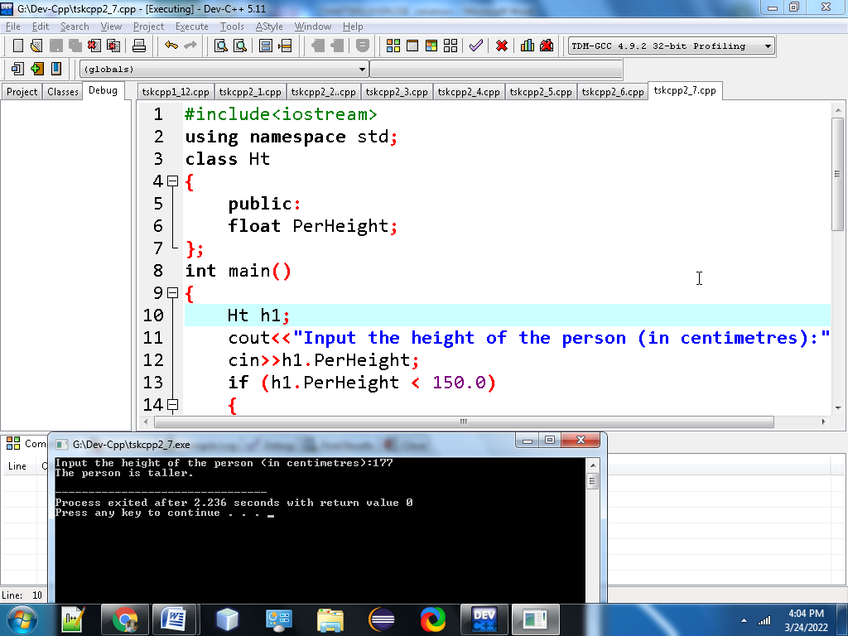

**8. Write a C++ program to find the largest of three numbers?**

**#include <iostream>**

**using namespace std;**

**class lar**

**{**

**public:**

**int n1, n2, n3;**

**};**

**int main()**

**{**

**lar lg;**

**cout<<"Enter three numbers:";**

**cin>>lg.n1>>lg.n2>>lg.n3;**

**if (lg.n1 >= lg.n2 && lg.n1 >=lg.n3)**

**{**

**cout<<"the largest number is:"<<lg.n1;**

**}**

**else if (lg.n2 >=lg.n1 && lg.n2 >= lg.n3)**

**{**

**cout<<"the largest number is:"<<lg.n2;**

**}**

**else**

**{**

**cout<<"the largest number is:"<<lg.n3;**

**}**

**return 0;**

**}  
Output:**

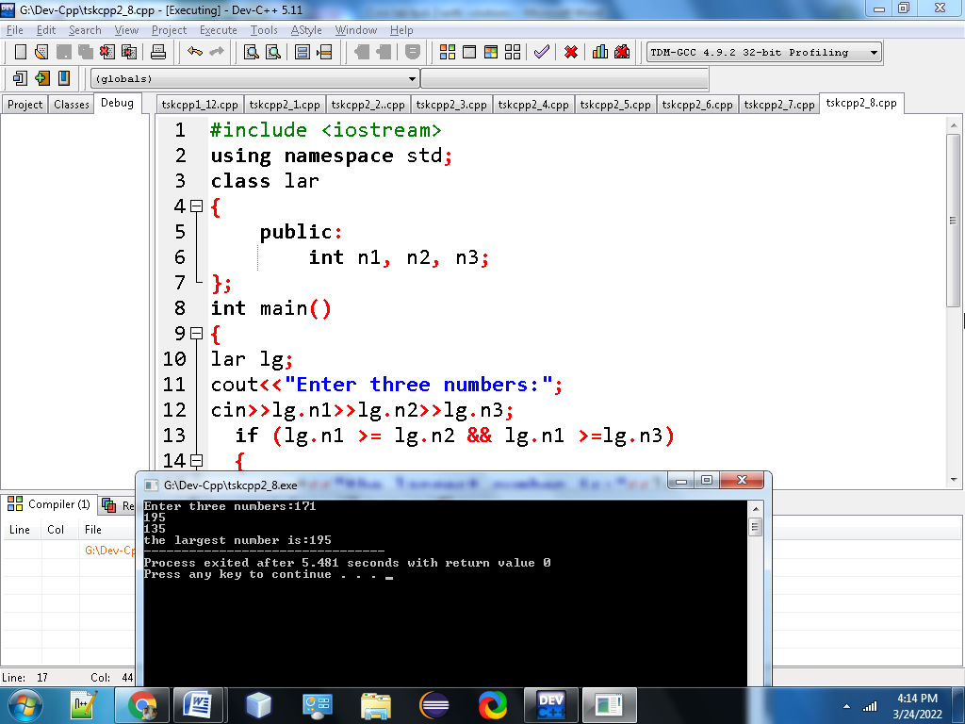

**9.Write a C++ program to accept a coordinate point in a XY coordinate system and determine in which quadrant the coordinate point lies?**

**#include<iostream>**

**using namespace std;**

**class cor**

**{**

**public:**

**int co1,co2;**

**};**

**int main()**

**{**

**cor cr;**

**cout<<"Input the values for X and Y coordinate:";**

**cin>>cr.co1>>cr.co2;**

**if(cr.co1 > 0 && cr.co2 > 0)**

**{**

**cout<<"The coordinate point"<<cr.co1<<","<<cr.co2<<"lies in the First quandrant";**

**}**

**else if(cr.co1 < 0 &&cr.co2 > 0)**

**{**

**cout<<"The coordinate point"<<cr.co1<<","<<cr.co2<<"lies in the Second quandrant";**

**}**

**else if(cr.co1 < 0 &&cr.co2 < 0)**

**{**

**cout<<"The coordinate point"<<cr.co1<<","<<cr.co2<<"lies in the Third quandrant";**

**}**

**else if( cr.co1 > 0 && cr.co2 < 0)**

**{**

**cout<<"The coordinate point"<<cr.co1<<","<<cr.co2<<"lies in the Fourth quandrant";**

**}**

**else if( cr.co1 == 0 && cr.co2 == 0)**

**{**

**cout<<"The coordinate point"<<cr.co1<<","<<cr.co2<<"lies at the origin.";**

**}**

**return 0;**

**}**

**Output:**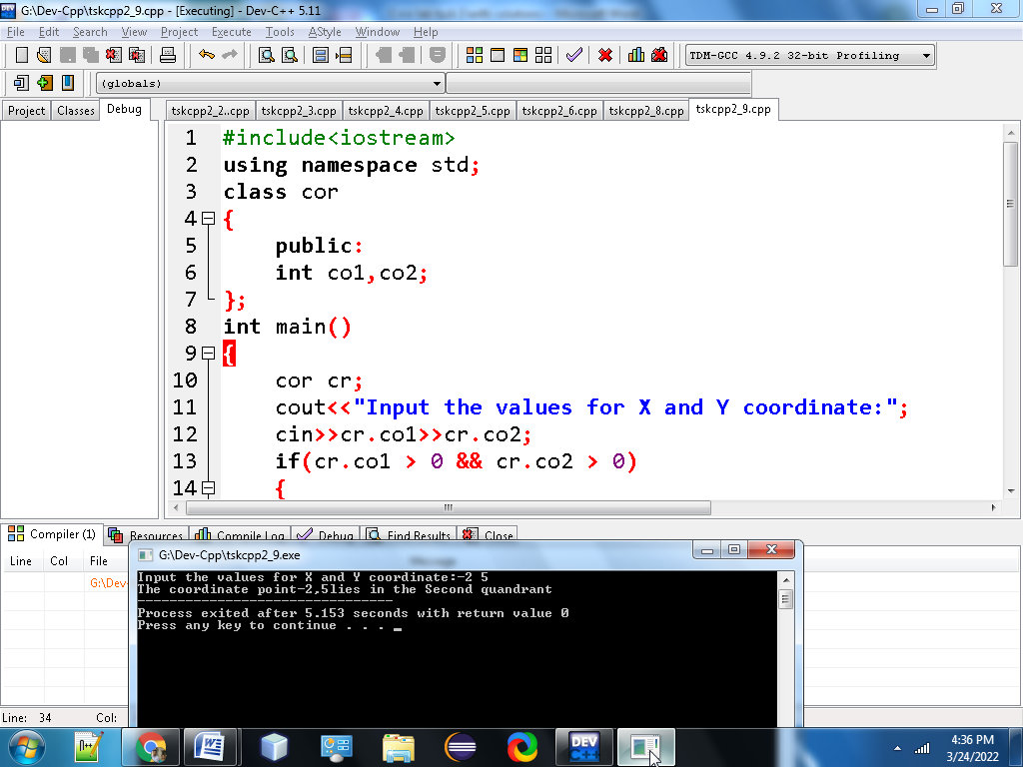

**10. Write a C++ program to read roll no, name and marks of three subjects and calculate the total, percentage and division.**

**#include<iostream>**

**using namespace std;**

**#include <string.h>**

**class stu**

**{**

**public:**

**int rl,phy,che,ca,total;**

**float per;**

**char nm[20],div[10];**

**};**

**int main()**

**{**

**stu st;**

**cout<<"Input the Roll Number of the student :";**

**cin>>st.rl;**

**cout<<"Input the Name of the Student :";**

**cin>>st.nm;**

**cout<<"Input the marks of Physics, Chemistry and Computer Application : ";**

**cin>>st.phy>>st.che>>st.ca;**

**st.total = st.phy+st.che+st.ca;**

**st.per = st.total/3.0;**

**if (st.per>=60)**

**{**

**strcpy(st.div,"First");**

**}**

**else if (st.per<60&&st.per>=48)**

**{**

**strcpy(st.div,"Second");**

**}**

**else if (st.per<48&&st.per>=36)**

**{**

**strcpy(st.div,"Pass");**

**}**

**else**

**{**

**strcpy(st.div,"Fail");**

**}**

**cout<<"Roll No :"<<st.rl<<endl;**

**cout<<"Name of Student:"<<st.nm<<endl;**

**cout<<"Marks in Physics:"<<st.phy<<endl;**

**cout<<"Marks in Chemistry:"<<st.che<<endl;**

**cout<<"Marks in Computer Application:"<<st.ca<<endl;**

**cout<<"Total Marks:"<<st.total<<endl;**

**cout<<"Percentage:"<<st.per<<endl;**

**cout<<"Division:"<<st.div;**

**return 0;**

**}**

**Output:**

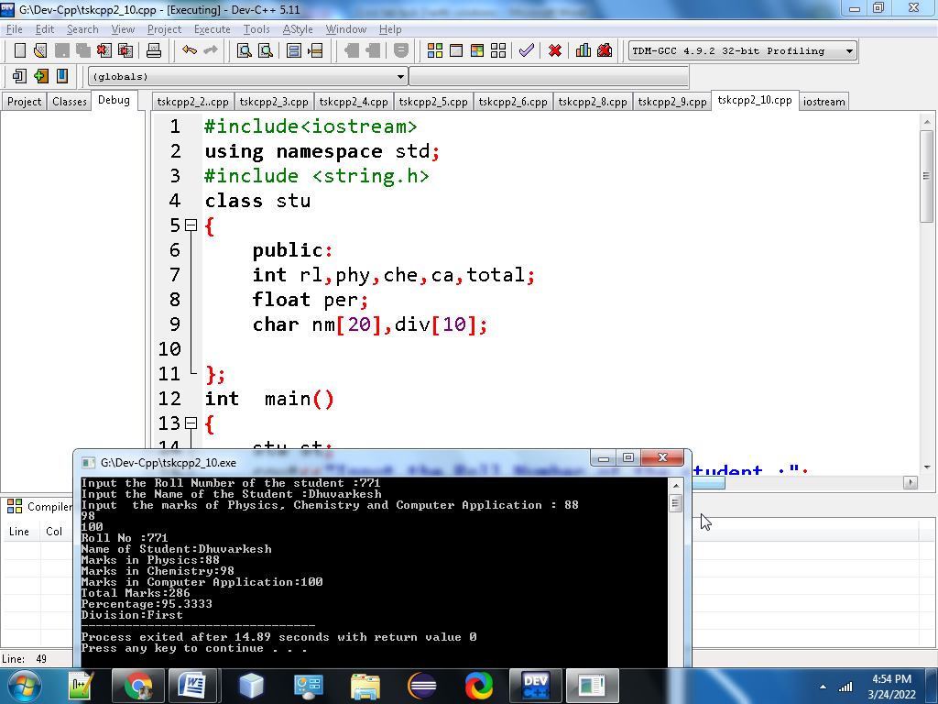

**11. Write a C++ program to check whether a triangle is Equilateral, Isosceles or Scalene?**

**#include<iostream>**

**using namespace std;**

**class tri**

**{**

**public:**

**int side1, side2, side3;**

**};**

**int main()**

**{**

**tri tr;**

**cout<<"Enter sides of triangle:";**

**cin>>tr.side1>>tr.side2>>tr.side3;**

**if(tr.side1 == tr.side2 && tr.side2 ==tr.side3)**

**{**

**cout<<"The Triangle is equilateral\n";**

**}**

**else if(tr.side1 == tr.side2 || tr.side2 == tr.side3 || tr.side3 == tr.side1)**

**{**

**cout<<"The Triangle is isosceles\n";**

**}**

**else**

**{**

**cout<<"The Triangle is scalene\n";**

**}**

**return 0;**

**}**

**Output:**

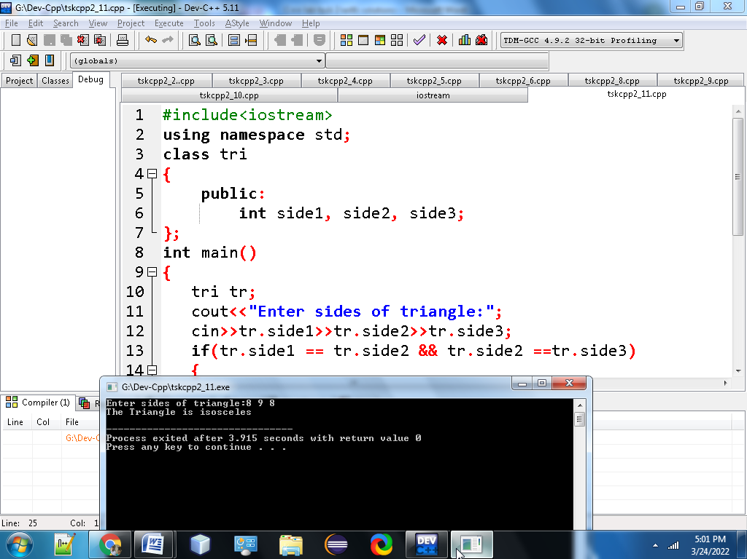

**12. Write a C++ program to check whether a triangle can be formed by the given value for the angles ?**

**#include<iostream>**

**using namespace std;**

**class angle**

**{**

**public:**

**int anga, angb, angc, sum;**

**};**

**int main()**

**{**

**angle ag;**

**cout<<"Input three angles of triangle :";**

**cin>>ag.anga>>ag.angb>>ag.angc;**

**ag.sum = ag.anga + ag.angb + ag.angc;**

**if(ag.sum == 180)**

**{**

**printf("The triangle is valid.\n");**

**}**

**else**

**{**

**printf("The triangle is not valid.\n");**

**}**

**return 0;**

**}**

**Output:**

